.NET Framework 4

**.NET Framework Versions and Dependencies**

Updated: September 2010

Each version of the .NET Framework contains the common language runtime (CLR) as its core component, and includes additional components such as the base class libraries and other managed libraries. This topic describes the key components of the .NET Framework versions, provides information about the underlying CLR versions and associated development environments, and identifies the versions that are installed by Windows.

The following illustration summarizes the version history and which versions are installed by Windows.

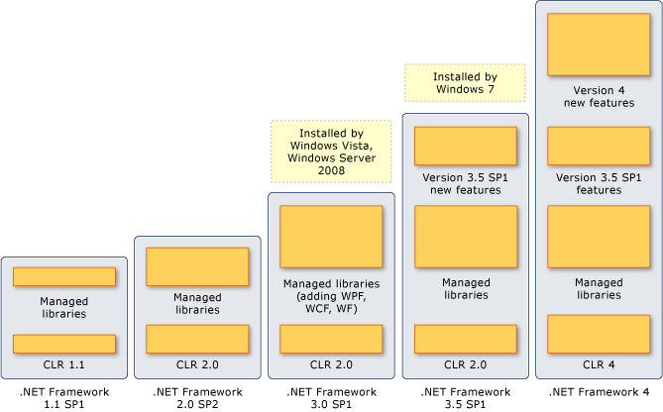

See [Installing the .NET Framework](http://msdn.microsoft.com/en-us/library/5a4x27ek.aspx) for information about installing the current version. For information about support for the .NET Framework, see [Microsoft .NET Framework Support Lifecycle Policy](http://go.microsoft.com/fwlink/?LinkId=196607) on the Microsoft Support Web site.

Description: http://i.msdn.microsoft.com/Global/Images/clear.gifFeatures Included in the .NET Framework Versions

Each new version of the .NET Framework retains features from the previous versions and adds new features. Although the CLR is the core component of the .NET Framework, the CLR is identified by its own version number apart from the .NET Framework version number. Some versions of the .NET Framework include a new version of the CLR, but others use an earlier version. For example, the .NET Framework version 4 includes CLR version 4, but the .NET Framework 3.5 includes CLR 2.0. (There was no version 3 of the CLR.) The version of the CLR on which an application is running can be determined by retrieving the value of the [Environment..::.Version](http://msdn.microsoft.com/en-us/library/system.environment.version.aspx) property.

You do not have to install previous versions of the .NET Framework or the CLR before you install the latest version; each version provides the necessary components.

The following table provides a brief review of the .NET Framework versions and the associated CLR version. It also shows the Visual Studio version that provided the development environment when that version of the .NET Framework was introduced. However, with the multi-targeting feature of Visual Studio, you are not limited to only that version of the .NET Framework.

|  |  |  |  |
| --- | --- | --- | --- |
| **.NET Framework version** | **CLR version** | **Visual Studio version** | **Description** |
| 1.0 | 1.0 | Visual Studio .NET | Contained the first version of the CLR and the first version of the base class libraries. |
| 1.1 | 1.1 | Visual Studio .NET 2003 | Included updates to ASP.NET and ADO.NET. This version was subsequently updated twice, with Service Pack 1 (SP1) and SP2. This version also introduced side-by-side execution, which enables applications on a single computer to run against multiple versions of the CLR. |
| 2.0 | 2.0 | Visual Studio 2005 | Introduced a new version of the CLR with additions to the base class libraries, including generics, generic collections, and significant additions to ASP.NET. This version was subsequently updated with SP1 and SP2. |
| 3.0 | 2.0 | Visual Studio 2005 | This version is essentially .NET Framework 2.0 with the addition of Windows Presentation Foundation (WPF), Windows Communications Foundation (WCF), Windows Workflow Foundation (WF), and CardSpace. It was subsequently updated with SP1 and SP2. |
| 3.5 | 2.0 | Visual Studio 2008 | Added new features such as AJAX-enabled Web sites and LINQ. The SP1 update added the .NET Framework Client Profile, Dynamic Data, and a small set of additional enhancements. |
| 4 | 4 | Visual Studio 2010 | Includes a new version of the CLR, expanded base class libraries, and new features such as the Managed Extensibility Framework (MEF), dynamic language runtime (DLR), and code contracts. |

Description: http://i.msdn.microsoft.com/Global/Images/clear.gifWindows Installations of the .NET Framework

Some versions of the .NET Framework are installed automatically with the Windows operating system, but other versions must be installed separately. The following table identifies the .NET Framework versions and whether they are integrated into the installation of Windows or must be installed separately.

|  |  |
| --- | --- |
| **.NET Framework versions** | **Windows versions** |
| 1.0, 1.1, and 2.0 | Not installed as part of the Windows operating system, but can be installed separately on Windows XP and earlier versions of Windows. |
| 3.0 (and 2.0 SP2, which provides support for versions 3.0 and 3.5) | Installed by Windows Vista and Windows Server 2008. |
| 3.5 SP1 | Installed by Windows 7. |
| 4 | Not installed as part of the Windows operating system, but can be installed separately on Windows XP, Windows Server 2003, and later versions of Windows. |

See [.NET Framework System Requirements](http://msdn.microsoft.com/en-us/library/8z6watww.aspx) for a list of supported operating systems.